Hi all,

Due to latest requests regarding help with installing the Eclipse Oxygen IDE + extension required to edit the PMR files (.proto files).
I have decided to investigate for better solutions that are less complicated to install and are more user friendly.

I have found a very nice proto editing extension for Visual Studio Code IDE (not Visual Studio).

Visual Studio Code is now the most widely used code editor across all the different platforms, Windows/Linux/Mac.
Visual studio code is a file-system based IDE, that is why it is most suited to this use case.

The vs code protobuf extension supports:
- syntax highlighting.
- syntax validation.
- code snippets.
- code completion.
- code formatting.
- brace matching.
- line and block commenting.
- compilation.

I have already made the boilerplate part of configuring the environment correctly.

Editing can still be done using Eclipse but I encourage you to try vs code.

Please follow the below instructions on how to install and use the new tooling.

- Download VS code. https://code.visualstudio.com/download
- After installing vs code, install the proto 3 extension.
https://marketplace.visualstudio.com/items?itemName=zxh404.vscode-proto3&ssr=false#overview
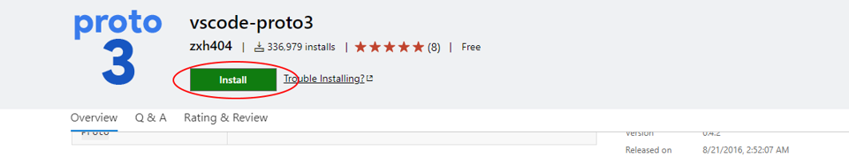
- Open Visual Studio code (should be on the desktop).
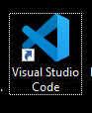
- Got to File => Open Folder
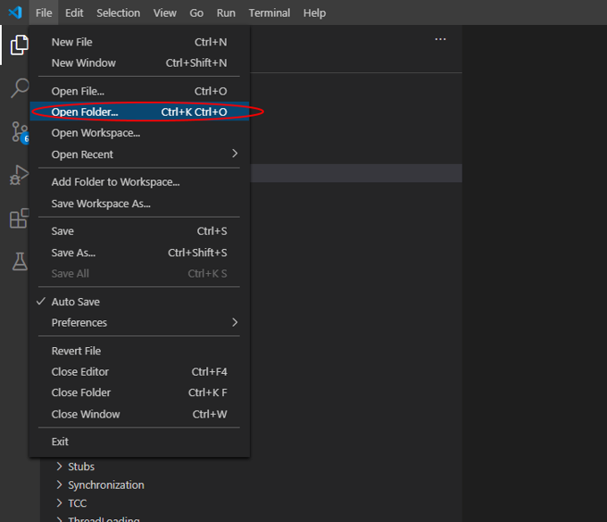
- Navigate to the Tango software repository and open the following folder (important):
Tango\Software\PMR\Messages
- Now you should see the "Messages" folder as your workspace:
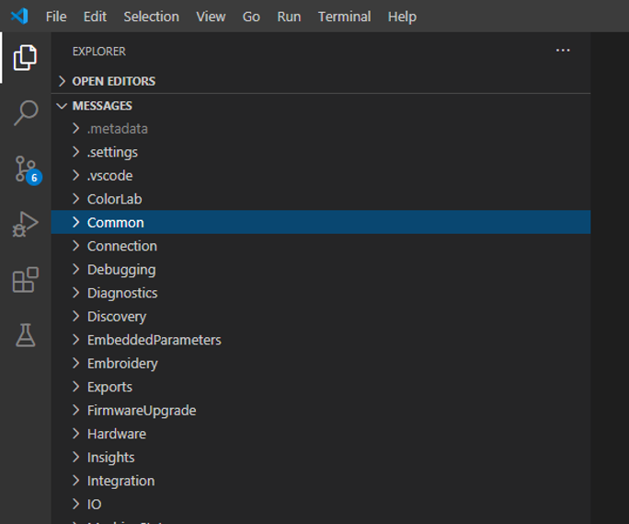
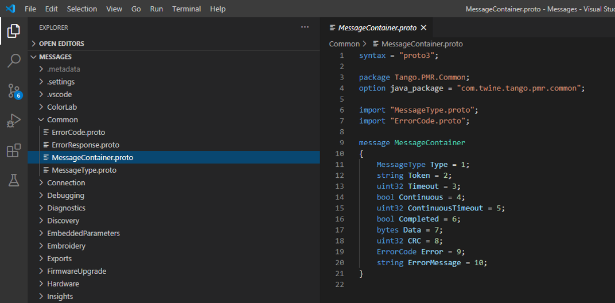
- Next, configure vs code to automatically save changes on files.
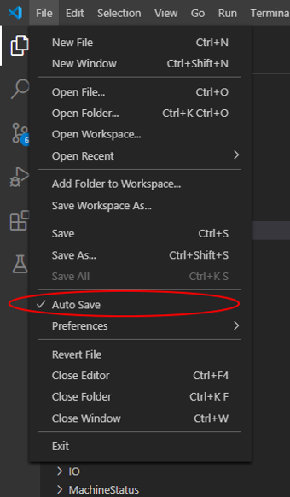
This will make the proto extension invalidate the proto syntax while your typing instead of saving.
Editing the proto import paths
Notice there is a new folder inside the "Messages" folder named ".vscode".
Inside that folder, there is a "settings.json" file with configuration.
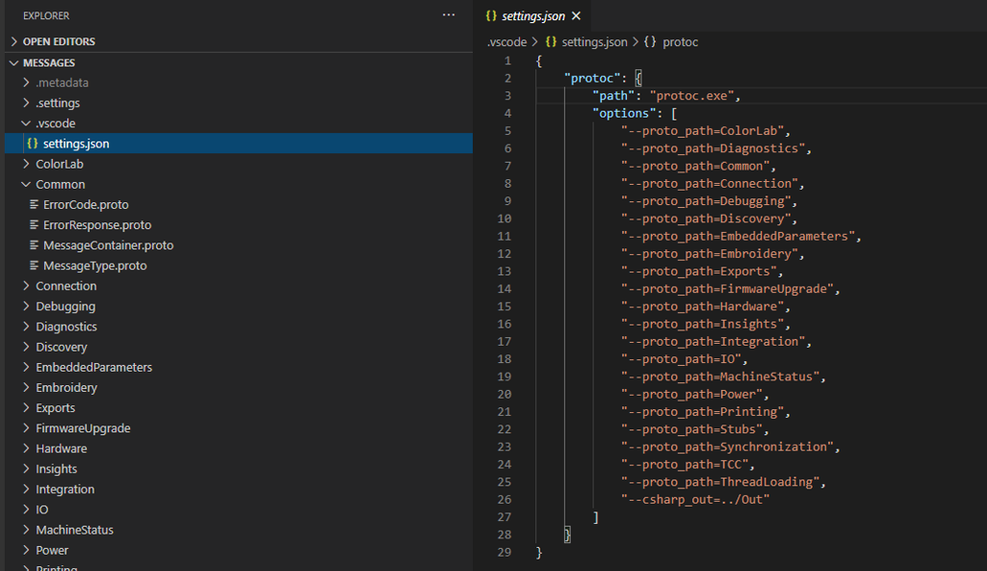
As you can see this file lets you specify folders that contains proto files.
This is required in order for the syntax validation to work properly.
I have already inserted all the current folder. Remember this if you add another folder.

True validation of ALL the PMR (optional)
When you finish editing your files, it is recommended to perform a complete temporary compilation of the entire workspace to make sure there are no errors.
To perform this compilation:
Type Ctrl+Shift+P inside vs code.
Then search for a task named "proto3: Compile All Protos".
This task will compile the entire workspace just so we can see if there are errors. (not to be confused with compiling with my custom compiler).
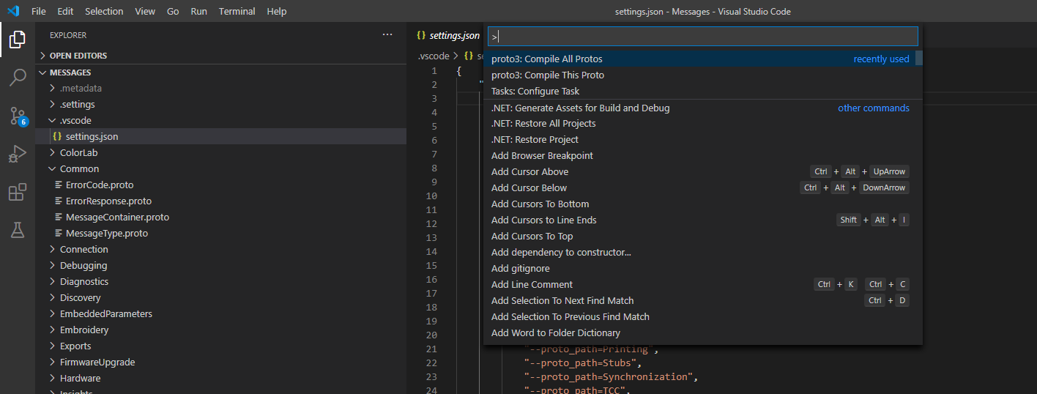

Sadly, there is now indication of a successful compilation, only when there are issues.

