Twine Tango Main Board Testing

Rev1.2
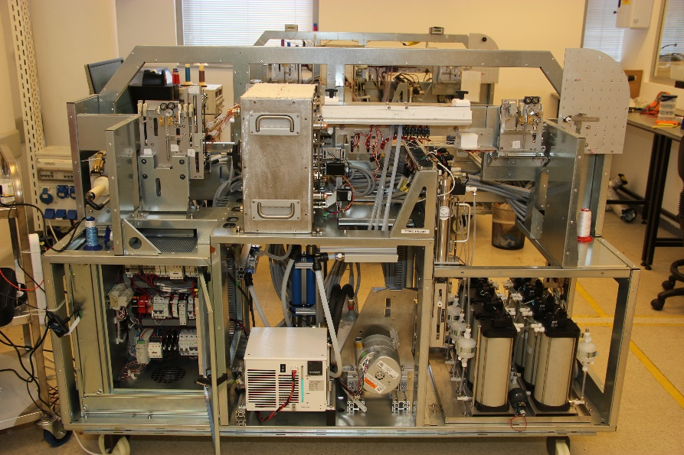
Revision History

Version | Date | Description
1.0 | 18/7/2018 | Initial preliminary version
1.1 | 05/08/2018 | Add Twine Logo. Update pictures

Introduction

Scope
- Twine Tango Main PCB – hence “DUT”
- DUT external connectivity testing

Purpose of Document
- Definition of Test Procedure.
- Documentation of how to perform all Main board test.

Document Outline
Section ‎2 Tango HW Test Plan .

Given
DUT will be tested in Tango printer with relevant assemblies. Hence not all connections will be tested.

Actions required by Tester during Testing

Motors
Observe that motors are moving when required.

Limit Switches
- Use an object to “cut” the light beam and observe result in Twine StubsGUI .

Encoders
- Turn/move mechanics attach to encoder and observe result in Twine StubsGUI.

Prerequisites

Items required
- Tango printer with all relevant assemblies. Assemblies shall be in a tested/working state
- Relevant cable interconnects between assemblies and electrical cabinet
- Electrical cabinet in a tested/working state
- USB type A to type B cable
- Twine StubsGUI
- Scripts
- “Tango_Main_PCB_ATP.xlsx” File for result.

Test Procedure

Initial steps

- Record DUT serial numbers, date and time in Excel sheet. (see picture below)

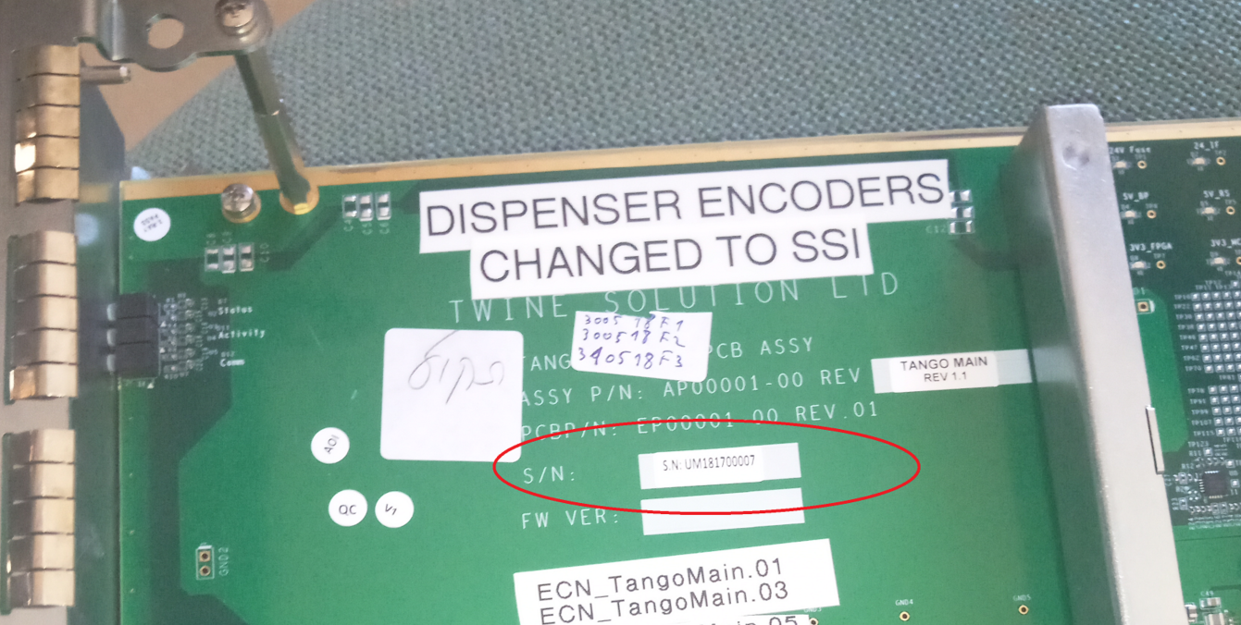

- Install DUT into electrical cabinet.
- Power on Tango printer (see picture below)

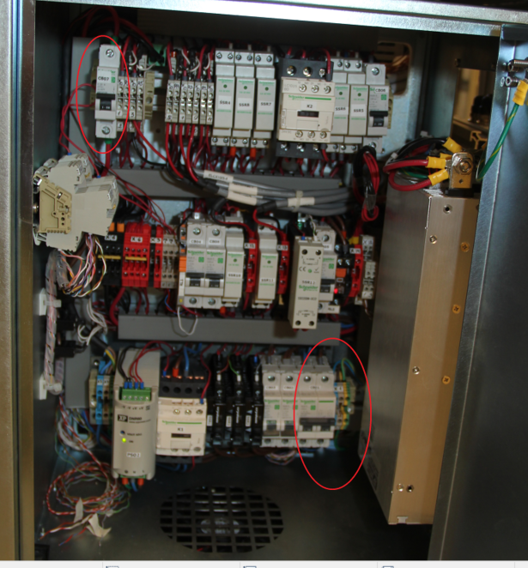

- Check if Status led on. If not press pushbutton switch on Cabinet

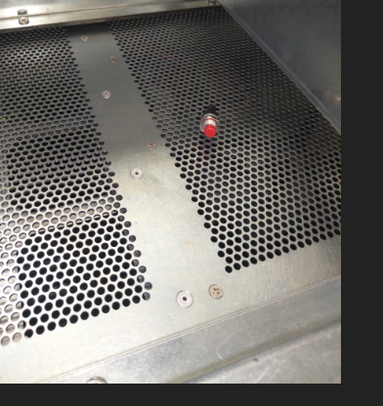
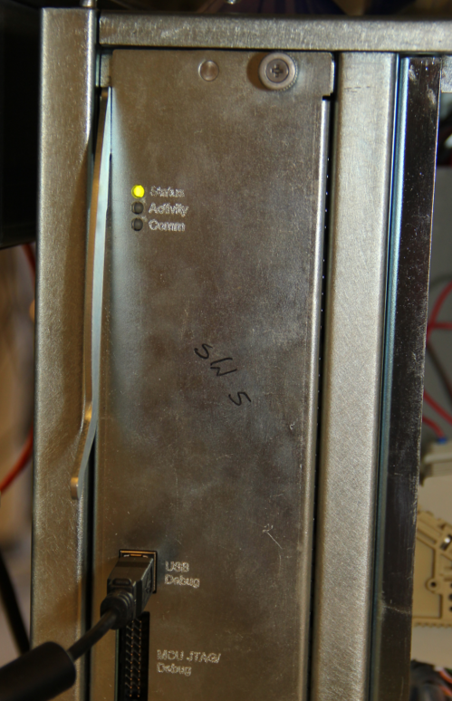

- Connect USB cable between DUT and PC
- Check on Device Manager, which new USB recognize.

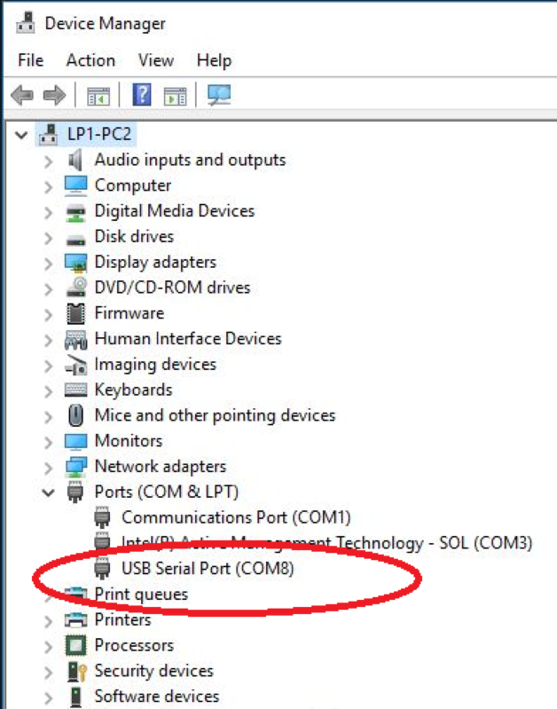

- Start the Tango StubsGUI and connect to DUT on 115200 and USB port that recognize.

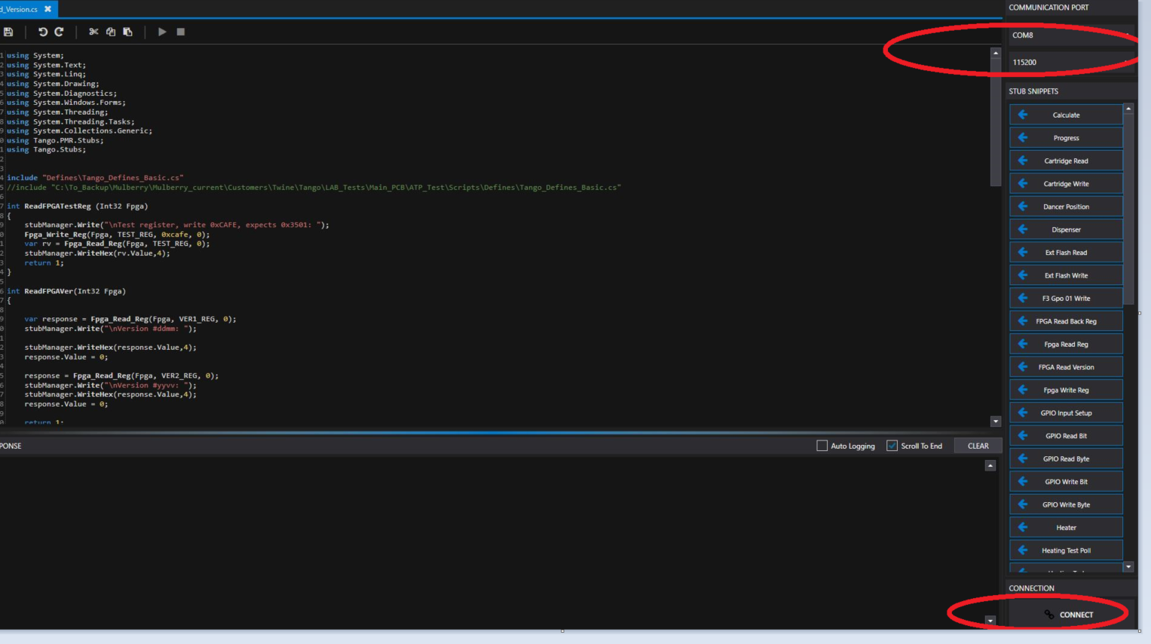

Read FPGAs Version.

- Open “D:\ATP_Test\Scripts\Read_Version.cs”
- Run script
- In line xy change the filename to match the DUT serial number
- Write DUT serial number on Excel (“F2” location).
- Execute the script and write s/w and FPGAs version into Excel sheet(F4 Location)

Read S/W Version.

- Open “D:\ATP_Test\Scripts\read embedded version.cs
- Run script
- Execute the script and write s/w version into Excel sheet(F5 Location)

Check Motors on RTFU.

- Open “D:\ATP_Test\Scripts\Assemblies\RTFU\RTFU_Motors.cs”
- Run script
- Check if all three motors rotates.

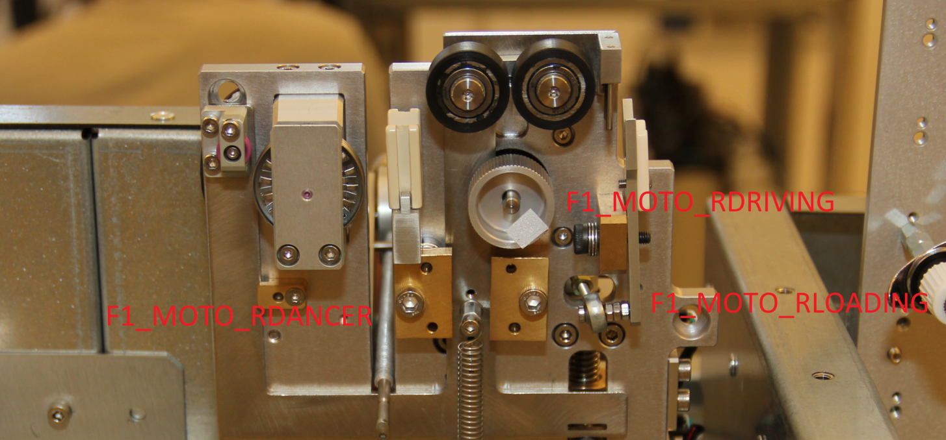

- Record results into Excel sheet (F6 Location)

Check Limit Switch on RTFU.

- Open “D:\ATP_Test\Scripts\Assemblies\RTFU\RTFU_LimitSwitch1.cs”
- Run script
- Activate each 5 limit switch once by inserting object which block light (see limit switch example)

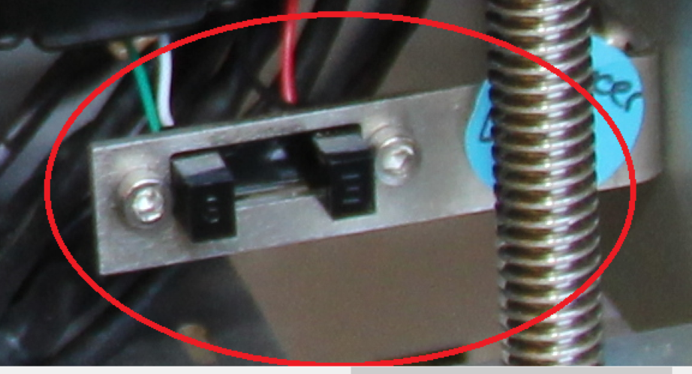

- Stop script when all limit switches change have been checked
- Record results into Excel sheet (F7 Location)

Check Dancer Arm and Speed Sensor on RTFU.

- Open “D:\ATP_Test\Scripts\Assemblies\RTFU\RTFU_SSI.cs”
- Run script
- Move Dancer Arm and Speed Sensor

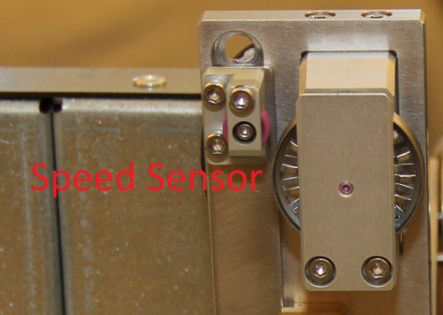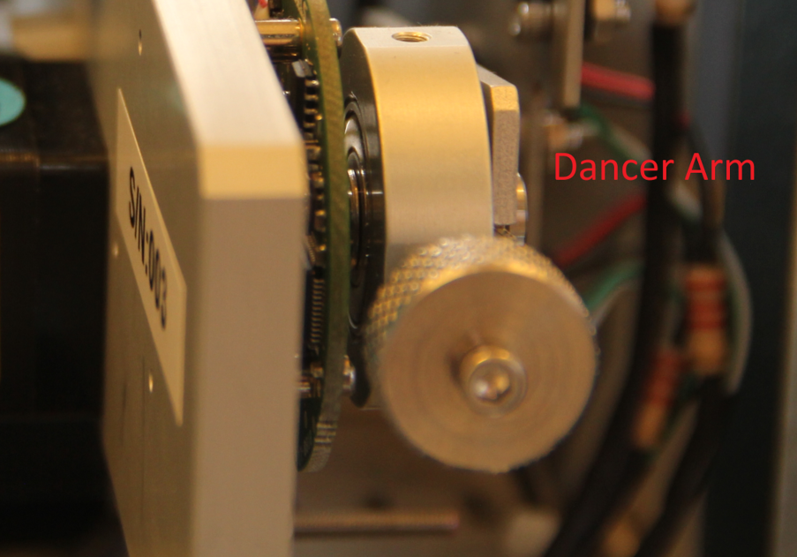

- Observe that register values changes.
- Stop script when both encoders have been checked.
- Record results into Excel sheet(F8 Location)

Check Motors on LTFU.

- Open “D:\ATP_Test\Scripts\Assemblies\LTFU\LTFU_Motors.cs”
- Run script
- Check if all four motors rotates.

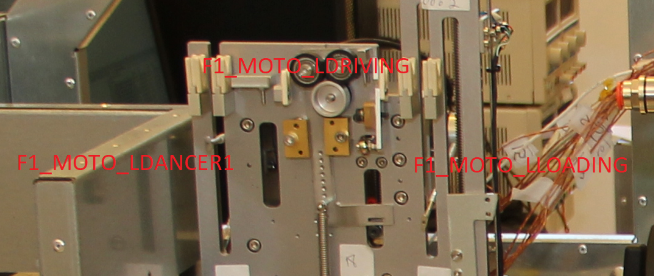

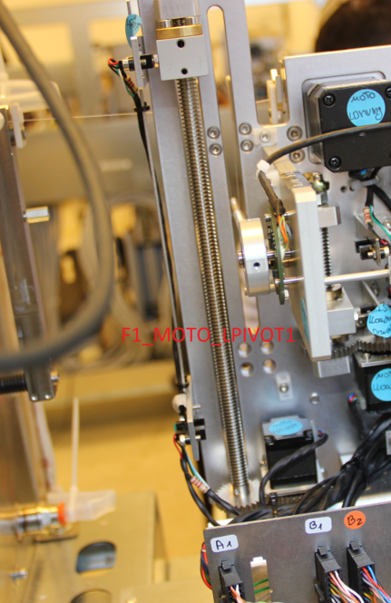

- Write Result into Excel sheet (F9 Location).

Check Limit Switch on LTFU.

- Open “D:\ATP_Test\Scripts\Assemblies\LTFU\LTFU_LimitSwitch.cs”
- Run script
- Activate each 6 limit switch once by inserting object which block light.
- Stop script when all limit switches change have been checked.
- Record results into Excel sheet (F10 Location).

Check Dancer Arm on LTFU.

- Open “D:\ATP_Test\Scripts\Assemblies\LTFU\LTFU_SSI.cs”
- Run script
- Move each dancer arm
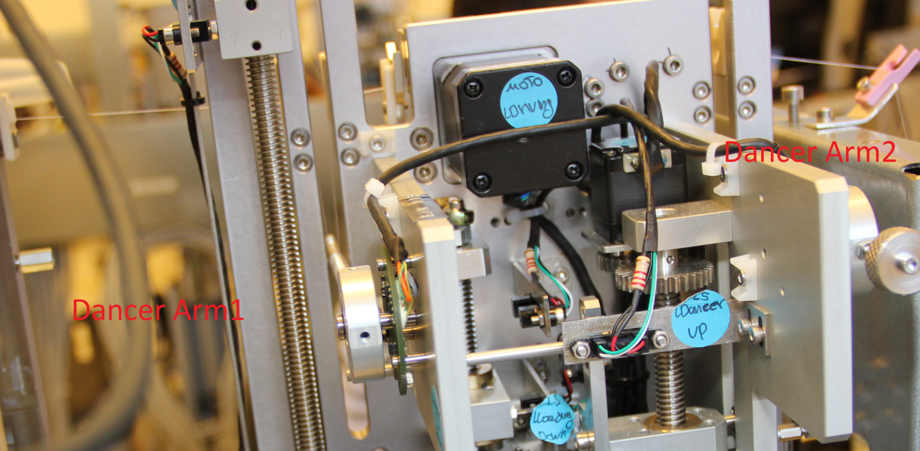

- Observe that register values changes
- Stop script when both encoders have been checked
- Record results into Excel sheet (F11 Location).

Check Motors on Winder.

- Open “D:\ATP_Test\Scripts\Assemblies\Winder\Winder_Screw_Motors.cs”
- Run script
- Check if all two motors rotates.

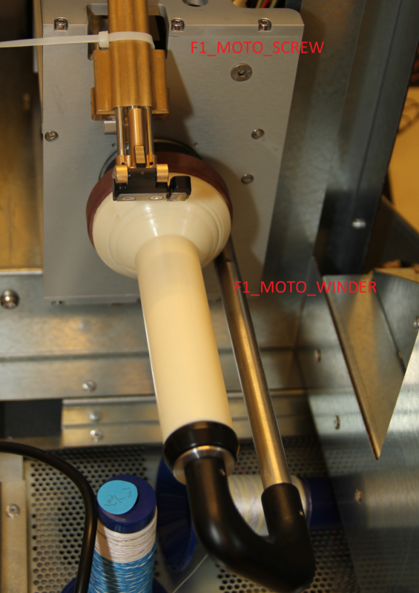

- Write Result into Excel sheet (“F12” location).

Check Limit Switch on Winder.

- Open “D:\ATP_Test\Scripts\Assemblies\winder\winder_LimitSwitch.cs”
- Run script
- Activate each 4 limit switch once by inserting object which block light.
- Stop script when all limit switches change have been checked.
- Record results into Excel sheet (“F13” location).

Check Motors on Dryer.
- Open “D:\ATP_Test\Scripts\Assemblies\Dryer\Dryer_Motors.cs
- Run script
- Check if all two motors rotates.

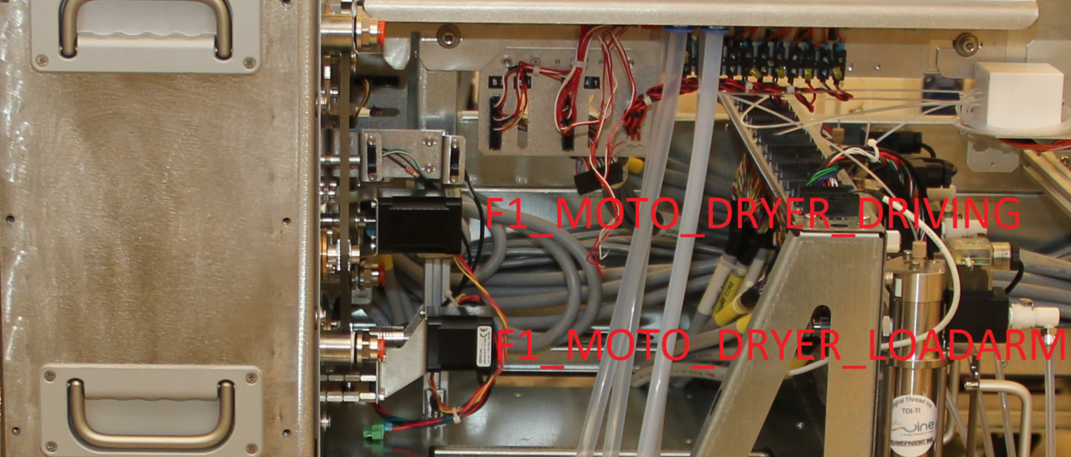

- Write Result into Excel (“F14” location).

Check Limit Switch on Dryer.
- Open “D:\ATP_TEST\Scripts\Assemblies\Dryer\Dryer_LimitSwitch.cs”
- Run script
- Activate each 2 limit switch once by inserting object which block light.
- Stop script when all limit switches change have been checked.
- Record results into Excel sheet (“F15” location).

Check SSRs on Dryer.
- Open “D:\ATP_Test\Scripts\Assemblies\Dryer\Dryer_SSR.cs”
- Run script
- Check if 3 Leds turn on and off one by one.

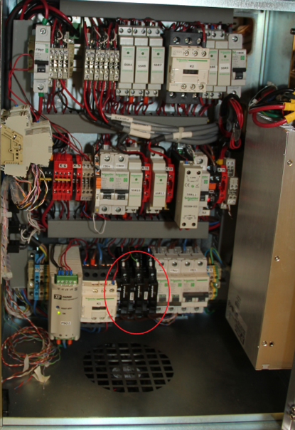

- Write Result into Excel sheet (“F16” location).

Check Midtank_Valves.
- Open “D:\ATP_Test\Scripts\Assemblies\MidTank\Midtank_Valves.cs
- Run script at least 8 times, once pr. Midtank.
- Enter Midtank number to test (1-8)
- Observe, by listening and feeling, that valve is moving back and forth twice.

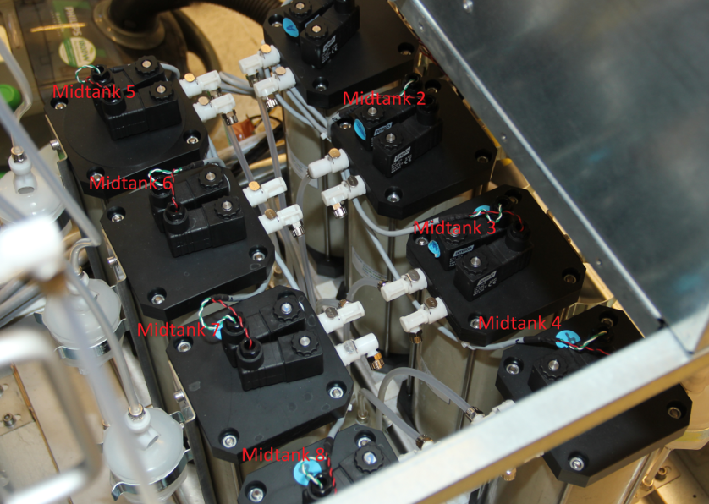

- Record results into Excel sheet (“F17” location).

Check Midtank_pressure_sensors.
- Open “D:\ATP_Test\Scripts\Assemblies\MidTank\Midtank_pressure_sensors.cs
- Connect connectors with resistors on it ,to J0172 and J0282 .
The connector must connect to 5V power supplay.

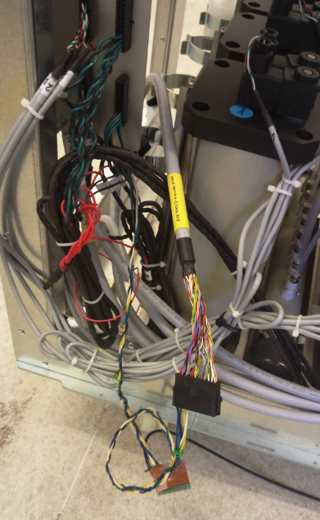

- Run script
- Observe ADC value reported by script
Record result into Excel sheet.it should be between two values.

Check Dispenser 3WValve.
- Open “D:\ATP_Test\Scripts\Assemblies\Dispenser\Dispenser_3WValve.cs
- Run script at least 8 times, once pr. Dispenser.
- Enter dispenser number to test (1-8).
- Observe, by listening, that valve is moving back and forth.

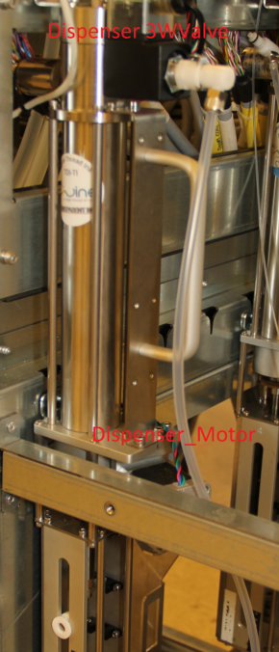

- Record results into Excel sheet (“E19” location).

Check Limit Switch on Dispenser.

- Open “D:\ATP_Test\Scripts\Assemblies\Dispenser\Dispenser_LimitSwitch.cs
- Run script at least 8 times, once pr. Dispenser
- Enter dispenser number to test (1-8):
- Activate each 4 limit switch once by inserting object which block light.
- Stop script when all limit switches change have been checked.
- Record results into Excel sheet .

Check Motors on Dispenser.

- Open “D:\ATP_Test\Scripts\Assemblies\Dispenser\Dispenser_Motors.cs
- Run script at least 8 times, once pr. Dispenser
- Observe Dispenser motor is moving back and forth
- Record Result into Excel sheet .

Check Pressure Sensor on Dispenser.

- Open “D:\ATP_Test\Scripts\Assemblies\Dispenser\Dispenser_PressureSensor.cs
- Run script.
- Observe ADC value reported by script
- Record Result into Excel sheet. It’s should be 514mv.

Check ElectricalEnclosure_Fans.

- Open “D:\ATP_Test\Scripts\Assemblies\ElectricalEnclosure\ElectricalEnclosure_Fans.cs
- Run script.
- Observe Tacho value reported by script
- Record Result into Excel sheet Only Tacho 1 should be #04C4 .all other should be #0000

Check PT100 (temperature sensor )

- Open “D:\ATP_Test\Scripts\Assemblies\Other\PT100__Horizontal_Printing.cs”
- Run script.
- Observe 12 value temperature by script. Its should be around 24 Degree
- Record Result into Excel sheet.

