Development Release Notes
  - Machine Studio v4.2 | PPC v1.2 | FSE v1.1

The Data Store
The Data Store is a new way of sharing data between the different Twine applications though a common interface for querying and storing data.
The motivation is to unify the way we store and obtain different calibration and configuration data without the need to implement and develop special mechanism, interface and protocols for each new requirement.
This will allow the development team, especially the embedded team, to deliver new functionality rapidly, that will work end-to-end out of the box!
The Data Store is composed of collections, each collection has a name and a collection of key-value pairs.
Each key in the data store must be unique within its own collection.
This means that for an application to query a data store value, it must specify a collection name and a key.
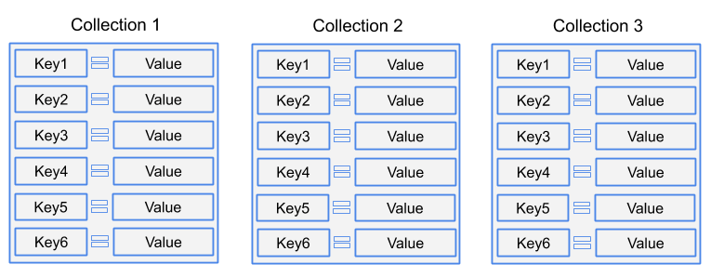
Local vs Global Data Store
As the title suggests, there are two separate data stores, one is the “Local” or “Machine” data store, which is designed to store data relevant to a specific machine.
While the global data store contains data that will be shared across all machines.
The local and global data stores can contain identical collections with identical keys.
This is useful when we want to override a global data store value from the local data store.
Client applications are not aware of this concept of two separate data stores. They only need to query the required collection and key.
The back-end interface will determine which of the values (global or local) should be returned.
Data Store Value Types
The data store currently supports the following value types.
- Int32 - (32 bit integer number)
- Float - (single precision number)
- Double - (double precision number)
- Boolean - (yes/no)
- String - (sequence of characters)
- Bytes - (array of bytes)
- Proto - (a complex protobuf message from the PMR)

Accessing and Managing Data Stores
The global data store and local (machines) data stores will be accessed using the following methods.
- Firmware => PPC: The embedded firmware device will be able to access the data store through a request/response API (current firmware to PPC communication).
- Tango FSE Configuration Module => PPC/Cloud: Tango FSE will expose a machine’s data store through the new configuration module.
Updating a machine’s data store via FSE will first update the cloud database.
When a machine is actively connected, FSE will also update the PPC and Firmware immediately.
- Tango FSE Procedures => PPC: Procedures can access the machine’s data store through a dedicated API.
- Third Party Partners => Web API: Twine cloud services will expose a public protected API which allows full control over the data store. (permissions required).
- Data Store Command Prompt Utility => Web API: The dsUtil is the only tool that allows managing the global data store.
The global data store ideally, should be a part of the software version.
Data Store Synchronization
In order for a machine to be updated on the latest data store definitions, it needs to hold an updated versions of the global data store and its own local data store.
The global data store will be updated (One-Way) through the standard PPC database update.
The local data store is a bit more complicated, as it can have changes on the local machine’s data store and also in the cloud. Therefore, the machine’s data store will be synchronized using the PPC synchronization pass (supports Two-Way).
The synchronization pass is the mechanism that takes care of synchronizing the machine’s diagnostics data to the cloud. (Job Runs, Events, Update Statuses, Jobs etc.)

Data Store Flow
Below you can find a diagram describing the overview details of how the Data Store works.
Pay close attention to one-way vs two-way arrows.
